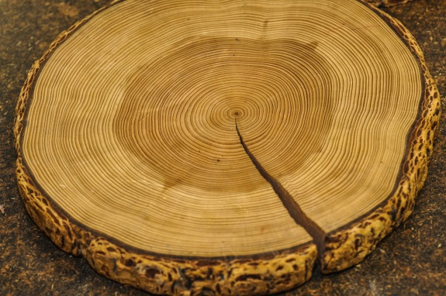
St Mark’s Episcopal Church
18313 Lappans Road
Boonsboro, MD 21713
301-582-0417
Stmarkslappans.org
Stewardship Season, October 2016

What does it take to grow a tree?
Tree rings show that some years
When sun and light, water and nutrients are abundant,
Trees grow quickly.
But in other years when there is drought
When nutrients are locked in the soil and when light is dim
Trees grow more slowly.

What does it take to grow a Church?
When resources are abundant,
When members give prayer and time and love
Churches can grow quickly.
But in other years when resources are slim,
Churches grow more slowly….or not at all…or decline and fade.

What do you want for St. Mark’s in 2017?
Your Rector and Vestry hope you will want
to continue the growth in our Sunday School, our membership, our programs,
our outreach and pastoral care;
support vital, deeply spiritual worship, a well-kept campus;
keep our buildings ready for use by the church and community;
provide a staff to answer your calls, prepare schedules and materials for worship,
track of our finances, and lead our music ministry;
and sustain a full-time Rector, providing pastoral coverage 24/7/365, and spiritual leadership.

YOU provide the resources
Which make it possible to support a Church growing in love, in service, in prayer, in outreach,
A Church that matures in Christ, bearing the fruits of the Holy Spirit;
a branch of the Jesus Movement;
a Church that is takes care of the flock entrusted to us by God.

Your gift, your pledge, your commitment of time and ability,
Can help our Church Grow and Flourish
Like a Tree of Life!

