Electronic Giving Cards

These colorful laminated cards offer parishioners who pay their pledges online with a way to have their offerings blessed during worship services.

Congregations can customize this card for their own use. Former St. Anne’s treasurer Tyler Schleicher recommends printing them on a colorful card stock with the words “Electronic Giving” and “I Give Electronically” prominently featured as a way to inform others of the online giving option.

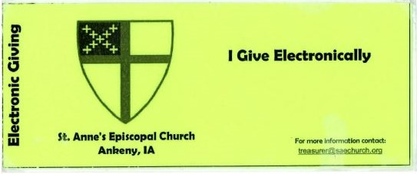

Cards are given to parishioners when they sign up for automatic withdrawal with more cards available in the church office. Laminating the cards helps them stand up to repeated use.

